Mandatory Template 3: Notification regarding the Board of Management’s review of the Child Safeguarding Statement

To: The Parents Association SMGS, Chairperson Sharon Breslin

The Board of Management of Scoil Mhuire Gaan Smál (17083B) wishes to inform you that:

• The Board of Management’s annual review of the school’s Child Safeguarding Statement was completed at the Board meeting of 13/09/2023

• This review was conducted in accordance with the “Checklist for Review of the Child Safeguarding Statement” published on the gov.ie website

Signed 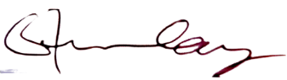Date 14/09/2023

Chairperson, Board of Management

Signed 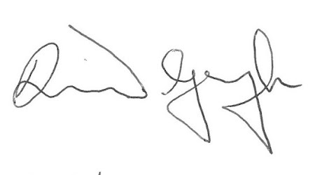Date 14/09/2023

Principal/Secretary to the Board of Management

